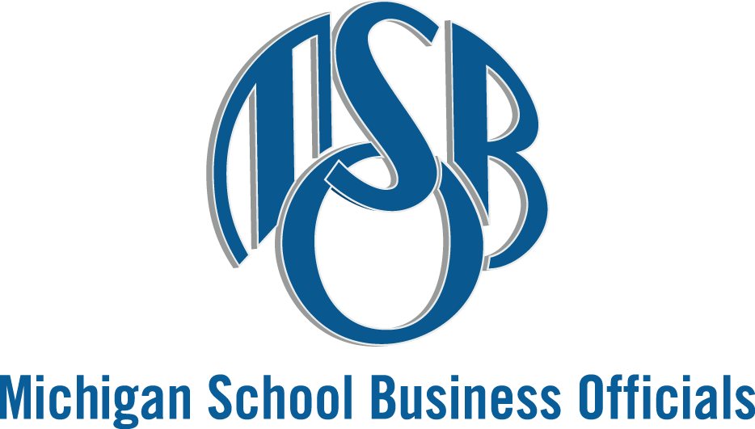

MSBO Human Resources Committee Town Hall
Zoom Meeting • Friday, January 24, 2025
9:00 AM – 10:30 AM

AGENDA

Chair: Scott Sawyer, Saginaw ISD

- Welcome/Introductions – Bob Dwan, MSBO; Scott Sawyer, Saginaw ISD

- Overview and Why: the MSBO Human Resources Committee/ Committee Discussion – Bob Dwan, MSBO; Scott Sawyer, Saginaw ISD

- Legislative/ Legal Update – Scott Sawyer, Saginaw ISD

- MSBO Update – Bob Dwan, MSBO

- Roundtable

Next Meetings:
Friday, February 28, 2025 • 9:30 AM
Friday, March 28, 2025 • 9:30 AM

