Kent Intermediate School District
Lincoln Campus

860 and 862 Crahen Road Northeast
Grand Rapids, Michigan 49525
Grand Rapids Charter Township

18 September 2024





Incident Command Approval: ________________________

Name and Title:

Date:

The information contained in this Incident Action Plan has been determined to be SENSITIVE AND CONFIDENTIAL under Michigan Law. ALL FOIA requests MUST be made to and through the Kent County Sheriff’s Office before dissemination.

Incident Action Plan (IAP) Committee:

All parties listed below agree that this plan is sufficient to support public safety during this event, this plan can be altered by Public Safety through the Incident Commander to ensure it is working to meet the needs of all disciplines involved.

Organization | Name | Date
Kent ISD | Sean Burns
Kent ISD | John Wittkowski
Kent ISD | Eric VanDyke
Kent ISD | Kyle Raymond
Lincoln Developmental Center | Todd Jones
Lincoln School | David Breen
Grand Rapids Charter Township Supervisor | Michael DeVries
Grand Rapids Charter Township Fire Department | Chief Luke Werdon
Rockford Ambulance
Kent County Sheriff’s Office | Lt. John DeGroot
Emergency Management Coordinator | Scott Corbin
Deputy Emergency Management Coordinator
Training and Exercise Coordinator | Brian Stalsonburg
Emergency Preparedness Program Specialist | Alex Yared
Kent County Health Department | Mindy Hunsinger
Corewell Health | Doug DeVries
Kent County Communications Center | Jennifer Robinson
Kent County Road Commission | Mike Lehnertz
Kent County Communications Center | Eric Hutchinson
Kent County Board of Commissioners
Michigan State Police - EMHSD | Lt. Orville Theaker
Michigan State Police – Grand Rapids Post

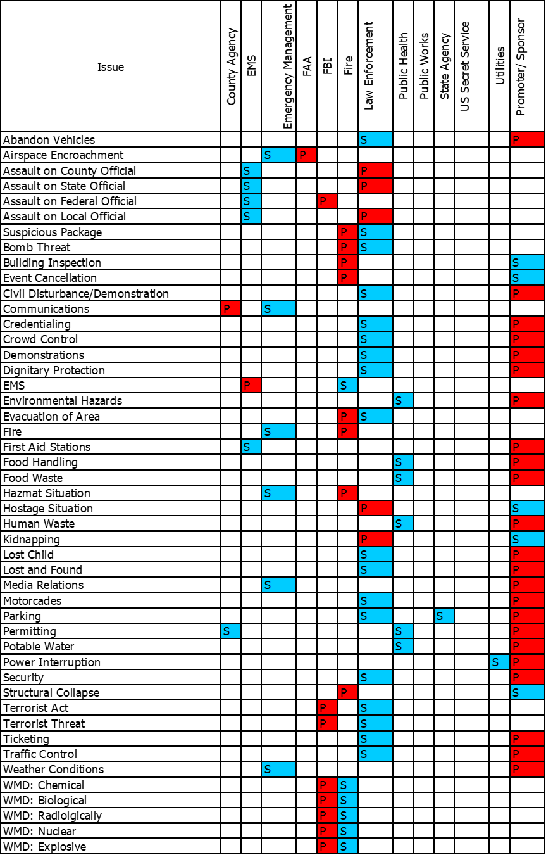

ICS 201: Incident Briefing
 | 1. Incident Name: KISD Lincoln Campus |  |  | 2. Incident Number: |  |  |  |  | 3. Date/Time Initiated: 18 July 2024 - 1400
4. Map/Sketch:
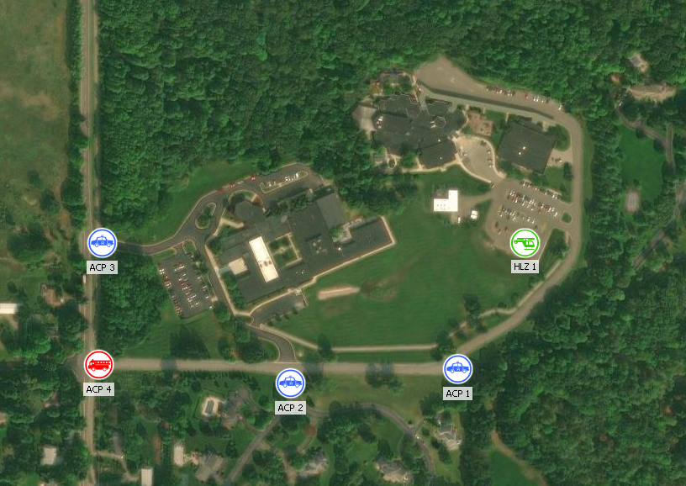
 | 5. Situation Summary and Health and Safety Briefing: The Lincoln Campus is comprised of two school facilities operated by the Kent Intermediate School District; Lincoln Developmental Center and Lincoln School. Lincoln Developmental Center is part of the Lincoln Campus continuum and serves students Kindergarten through age 26 whose needs are in the areas of severe multiple impairment, cognitive impairment, and autism spectrum disorder. Lincoln Campus serves students from the northern, central, and eastern sides of Kent County. Lincoln School is part of the Lincoln Campus continuum and serves students Kindergarten through age 26 whose needs are in the areas of severe multiple impairment, cognitive impairment, and autism spectrum disorder. Lincoln Campus serves students from the northern, central, and eastern sides of Kent County.
 | 6. Prepared by: Name: Alex Yared Position/Title: Planning Section Chief Signature:
 | ICS 201, Page 5 |  |  |  |  |  | Date/Time:
1. Incident Name: KISD Lincoln Campus |  | 2. Incident Number: |  |  |  |  |  |  |  | 3. Date/Time Initiated:  Date: 18 July 2024 Time: 1400
9. Current Organization (fill in additional organization as appropriate):
Unified Incident Command:
Kent ISD: David Breen (Lincoln School)
Todd Jones (Lincoln Developmental Center)

Fire and Rescue: Chief Luke Werdon

Law Enforcement: Lt. John DeGroot

EMS: Rockford Ambulance

Deputy Planning Section Chief:

Brian Stalsonburg
This is the initial organizational structure for event operations and initial incident response. UIC may alter it at any time as conditions dictate.
Emergency Operations Center:
EMC: Matt Groesser

DEMC: Scott Corbin
Operations Section Chief:

Planning Section Chief:

Alex Yared
Logistics Section Chief:

Finance Section Chief:

Kent ISD

Intelligence Section Chief:

KCSO DB
Public Information Officer: Sgt. Kailey Gilbert and Kent ISD
Safety Officer:
Liaison Officer: Sean Burns
6. Prepared by: Name: Alex Yared Position/Title: Planning Section Chief Signature:
ICS 201, Page 6 |  |  |  |  |  | Date/Time:
 | 1. Incident Name: KISD Lincoln Campus |  |  |  | 2. Incident Number: |  |  |  |  |  |  |  | 3. Date/Time Initiated:  Date: Time:
 | 10. Resource Summary:
 | Resource |  | Resource Identifier |  | Date/Time Ordered |  |  | ETA |  |  | Arrived | Notes (location/assignment/status)
 | 6. Prepared by: Name: Position/Title: Signature:
 | ICS 201, Page 7 |  |  |  |  |  | Date/Time:

Supplemental Incident Briefing Items
Scheduled Briefings:

Dial-In Information for NWS Weather Information: (616) 949-5150

Incident Facilities:
- Incident Command Post: Crahen Valley Township Park
- North Staging Area: Crahen Valley Township Park
- South Staging Area: MVP Crahen - 115 Crahen Avenue NE, Grand Rapids, MI 49525
- JIC/Media Staging Area: Crahen Valley Township Park
- Alternate JIC/Media Staging Area: Kent ISD Educational Services Center
- Reunification Facility: Calvary Church - 707 E Beltline Ave. NE, Grand Rapids, MI 49525

Communications:
- Refer to ICS 205: Incident Communications Plan and Supplemental Telephone Roster
- All Communication should flow through the ICS structure and Incident Command Post
Identification and Credentialing:

Perimeter and Access Control:
- Control Points will be manned as indicated below.

Maps:
- Maps are attached to this plan if you need a larger view, they will be located at the Incident Command Post (ICP).

Un-Attended and Suspicious Packages:
- All un-attended and suspicious packages should be reported to Incident Command. Incident command should follow agency protocol and request mutual aid as appropriate. Follow HOT Protocol:
  - H – Is it hidden?
  - O – Is it Obviously suspicious?
  - T – Is it Typical for the location?
If Yes, follow RAIN Protocol:
  - R – Recognize indications of a suspicious device
  - A – Avoid the area, keep others away
  - I – Isolate the area, establish a perimeter
  - N – Notify Unified Command and follow agency protocol

Additional Resources:
- Contact KCSO Dispatch to obtain additional resources

Access Control Points

ACP | Assigned | Agency | Personnel | Vehicles | Barricades | Location
1 | LE |  | 1 | 1 | 1 | Bradford Street at Bradford Farms Lane
2 | LE |  | 1 | 1 | 1 | Bradford Street at Bradford Farms Court
3 | LE |  | 1 | 1 | 1 | Crahen Avenue at Main Driveway
4 | Fire |  | 2 | 1 | 2 | Bradford Street at Crahen Avenue
5 | Fire |  | 2 | 1 | 1 | Crahen Avenue at Michigan Street
6 | Fire |  | 2 | 1 | 1 | Leonard Street in front of Crahen Valley Park
Totals |  |  | 9 | 6 | 7

Region 6 Mass Casualty Plan Levels

Region 6 Medical Control EMS Mass Casualty Incident Plan Levels:
- EMS Plan 1: 4-9 Patients
- EMS Plan 2: 10-24 Patients
- EMS Plan 3: 25+ Patients

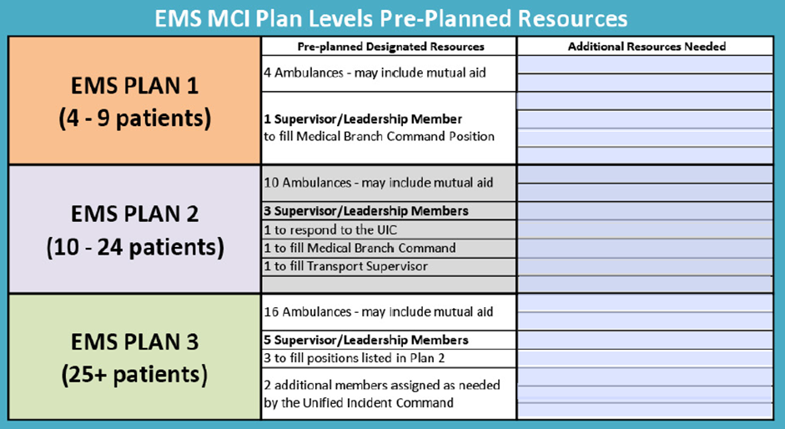

ICS 202: Incident Objectives
1. Incident Name: KISD Lincoln Campus |  |  |  | 2. Operational Period:  Time From: Time To:
3. Objective(s):
- Fire and Explosion Evacuation
- Severe Weather (Tornado Warning)
- Active Assailant Event

SEE NEXT PAGE FOR DETAILED INCIDENT OBJECTIVES
4. Operational Period Command Emphasis:
General Situational Awareness
5. Site Safety Plan Required? Yes No
Approved Site Safety Plan(s) Located at:


6. Incident Action Plan (the items checked below are included in this Incident Action Plan): ICS 203 ICS 208 Other Attachments:
ICS 204 ICS 210  Aeromedical Evacuation Supplement
ICS 205 ICS 214  NWS Weather Forecast
ICS 205A ICS 215A
 | ICS 206 ICS 220
7. Prepared by: Name: Alex Yared Position/Title: PCS Signature:
8. Approved by Incident Commander: Name: Signature:
ICS 202 |  |  | IAP Page: 10 |  | Date/Time:

Supplemental Incident Objectives

- Fire and Explosion Evacuation:
  - Sweep evacuation route and rally points for secondary threats
  - Evacuate staff and students to exterior rally points
  - Account for all staff and students
  - Be prepared to move to reunification location
- Severe Weather (Tornado Warning)
  - Sweep evacuation route and shelter locations for secondary threats
  - Evacuate staff and students to exterior shelter locations
  - Account for all staff and students
  - Be prepared to move to reunification location
- Active Assailant Event
  - Establish a Unified Command Post location a safe distance away from the incident, include school staff upon arrival.
  - Determine the nature of the threat, and report findings to other responders.
  - Upon arrival look for secondary devices and report suspicious vehicles or activity.
  - Determine safe routes for additional responders, upon arrival.
  - Once a contact team has been established to engage the suspect, proceed to eliminate threat.
  - Establish access control.
  - Determine hot, warm and cold zones.
  - Fire and EMS prepare for entry, maintain situational awareness. (include breaching tools and stretchers)
  - Direct fleeing people to warm zone and separate injured and non-injured at a Causality Collection Point (CCP).
  - Determine triage locations.
  - Determine staging locations,
  - Determine transport vehicles and routes.
  - Notify local hospitals, regarding AS/MCI.
  - Establish a security detail for Hospitals.
  - Determine air evacuation.
  - Request EOC Activation.
  - Establish a PIO, and briefing area.
  - Establish re-unification center for family members.
  - Establish accountability for students and staff
  - Determine transportation for low-priority students to the re-unification center.
  - Determine Joint Information Center to release information to the public.
  - Once scene is rendered safe all first responder personal will be sent to a de-briefing area before being sent home.

ICS 203: Organization Assignment List
1. Incident Name: KISD Lincoln Campus |  |  | 2. Operational Period:
3. Incident Commander(s) and Command Staff: |  |  |  |  | 7. Operations Section:
IC/UCs | Lt. John DeGroot |  |  |  | Chief
 | Chief Werdon |  |  |  | Deputy
 | Rockford Ambulance
 | Todd Jones or David Breen |  |  |  | Staging Area
Safety Officer |  |  |  |  | Branch
Public Info. Officer | Sgt. Kailey Gilbert and Kent ISD |  |  |  | Branch Director
Liaison Officer | Sean Burns |  |  |  | Deputy
4. Agency/Organization Representatives: |  |  |  |  | Division/Group
Agency/Organization |  | Name |  |  | Division/Group
 |  |  |  |  | Division/Group
 |  |  |  |  | Branch
 |  |  |  |  | Branch Director
 |  |  |  |  | Deputy
5. Planning Section: |  |  |  |  | Division/Group
Chief |  | Alex Yared |  |  | Division/Group
Deputy |  | Brian Stalsonburg |  |  | Division/Group
Resources Unit |  |  |  |  | Division/Group
Situation Unit |  |  |  |  | Division/Group
Documentation Unit |  |  |  |  | Branch
Demobilization Unit |  |  |  |  | Branch Director
Technical Specialists |  |  |  |  | Deputy
 |  |  |  |  | Division/Group
6. Logistics Section: |  |  |  |  | Division/Group
Chief |  |  |  |  | Division/Group
Deputy |  |  |  |  | Air Operations Branch
Support Branch |  |  |  |  | Air Ops Branch Dir.
Director
Supply Unit
Facilities Unit |  |  |  |  | 8. Finance/Administration Section:
Ground Support Unit |  |  |  |  | Chief | Kent ISD
Service Branch |  |  |  |  | Deputy
Director |  |  |  |  | Time Unit
Communications Unit |  |  |  |  | Procurement Unit
Medical Unit |  |  |  |  | Comp/Claims Unit
Food Unit |  |  |  |  | Cost Unit
9. Prepared by: Name: Alex Yared Position/Title: Planning Section Chief Signature:
ICS 203 |  | IAP Page: 12 |  | Date/Time:
ICS 204: Assignment List
1. Incident Name: KISD Lincoln Campus |  | 2. Operational Period:  Date From: Date To:  Time From: Time To: |  |  | 3.  Branch: Division: Group: Staging Area:
4. Operations Personnel: Name  Operations Section Chief: |  |  |  | Contact Number(s} | 3.  Branch: Division: Group: Staging Area:
Branch Director: Division/Group  Supervisor: |  |  |  |  | 3.  Branch: Division: Group: Staging Area:
5. Resources Assigned: |  |  | # of Persons | Contact (e.g., phone, pager, radio frequency, etc.) | Reporting Location,  Special Equipment and Supplies, Remarks, Notes, Information
Resource Identifier | -  Leader |  | # of Persons | Contact (e.g., phone, pager, radio frequency, etc.)
6. Work Assignments:
7. Special Instructions:
8. Communications (radio and/or phone contact numbers needed for this assignment):
Name/Function Primary Contact: indicate cell1 pager1 or radio (frequency/system/channel}
I
I
I
I
9. Prepared by: Name: Position/Title: Signature:
ICS 204 IAP Page: 13 |  |  | I Date/Time:

ICS 205: Incident Communications Plan (Blue Sky Day)

1. Incident Name: KISD Lincoln Campus |  |  |  |  | 2. Date/Time Prepared: |  |  |  |  |  |  | 3. Operational Period:  Date:  Time From: Time To:
4. Basic Radio Channel Use:
Zone Grp. | Ch # | Function | Channel Name/Trunked Radio System Talk Group |  |  | Assignment |  | RX Freq N or W | RX  Tone/NAC | TX Freq N or W | TX  Tone/NAC |  | Mode (A, D, or M)
 |  | Unified Incident Command | 41INT??
 |  | Primary LE Dispatch | 41PD?
 |  | Primary Fire Dispatch | 41FDE
 |  | Primary Medical Dispatch | 41RAAM
 |  | Primary Air Operations | AIRLZ1
5. Special Instructions: This 205 Form is for Blue Sky Day normal operations or special event operations. For Activate assailant incidents and other Mass Causalty Incidents, refer to ASHER 205 on the next page (Page 15)
6. Prepared by (Communications Unit Leader): Name: Alex Yared Signature:
ICS 205 |  |  |  | IAP Page: 14 |  |  | Date/Time:
ICS 205: Incident Communications Plan (ASHER 205)

1. Incident Name: KISD Lincoln Campus |  |  |  |  | 2. Date/Time Prepared: 26 June 2024 - 1530 |  |  |  |  | 3. Operational Period: Date:  Time From: Time To:
4. Basic Radio Channel Use:
Zone Grp. | Ch # | Function | Channel Name/Trunked Radio System Talk Group |  | Assignment | RX Freq N or W |  | RX  Tone/NAC | TX Freq N or W | TX  Tone/NAC | Mode (A, D, or M) | Remarks
 |  | Coordination | 41OPS4 |  | Unified Incident Command |  |  |  |  |  | D | UIC/Logistics/Operations/  Manager/Intelligence/SafetyPIO/EOC
 |  | Tactical | Primary Police Talk Group |  | LE/RTF Operations |  |  |  |  |  | D | Contact teams/Entry Corridor &  Casualty Collections Point/Force Protection
 |  | Staging | 41OPS1 |  | Link Up Location and Distant Staging |  |  |  |  |  | D | RTF/Staging Supervisor – Level 1 Staging of Protective and Rescue Elements for RTF and Distant Staging Area
 |  | Treatment, Triage and Transport | 41OPS2 |  | TECC/CCP/  Ambulance  Exchange Point |  |  |  |  |  | D | Active RTF/CCP Coordinator/  Medical Branch Director/Triage Patient Count & Priority/  Ambulance Exchange Point
 |  | Rescue/ALS | Primary Fire TG |  | Fire and EMS Apparatus |  |  |  |  |  | D | Staging Location and Critical Updates While Enroute. Switch Upon Check In with Staging
 |  | Site Security | 41OPS3 |  | Outer Perimeter |  |  |  |  |  | D | Force Protection for Outer Perimeter, Staging, ACP, CP, JIC and evacuation facilities.
 |  | Investigations/  Recovery | Local or State Event TG |  | LE Investigation |  |  |  |  |  | M | Investigative Support Agencies/Additional LE and Rescue Activities
5. Special Instructions: ASHER/MCI/DISASTER 205 Communications Plan: Following incident notification, Fire and EMS units will be dispatched on their primary talk groups to a secure staging area. Upon arrival, units will check in with the staging officer and await assignment to move to link up location or ambulance exchange point. Upon Completion of tactical RTF activities, Dispatch will relay talk group assignments to ensure interoperability for investigation and recovery operations.
6. Prepared by (Communications Unit Leader): Name: Alex Yared Signature:
ICS 205 |  |  |  | IAP Page: 15 |  |  | Date/Time: 26 June 2024 - 153

ICS 205A Communications List
1. Incident Name: KISD Lincoln Campus |  | 2. Operational Period: Date:  Time From: Time To:
3. Basic Local Communications Information:
Incident Assigned Position | Name (Alphabetized) |  | Methods of Contact
Lincoln Developmental Center | Main Office |  | (616) 410-4800
Lincoln Developmental Center Principal | Todd Jones |  | (616) 581-4306
Lincoln School | Main Office |  | (616) 410-4700
Lincoln School | Nurses Office |  | (616) 410-4706
Lincoln School Co-Principal | David Breen |  | (616) 240-8219
Lincoln School Co-Principal | Ashley Livingstone
Lincoln Campus Early Childhood Center | Main Office |  | (616) 447-5678
Lincoln Campus Early Childhood Center | Nurses Office |  | (616) 410-4830
Lincoln Campus Early Childhood Center | Nurses Office |  | (616) 410-4812
Lincoln Campus ECC Director | Ashley Karsten |  | (810) 422-7417
Kent ISD Transportation
Dean Transportation
Kent ISD Director of Security | Sean Burns |  | (616) 477-7272
Kent ISD Regional Security Coordinator | John Wittkowski |  | (616) 745-3326
Kent ISD Protective Intelligence Analyst | Kyle Raymond |  | (616) 914-3206
KCSO Community Services | LT. John DeGroot |  | (616) 485-4503
KCSO School Resource Officer | Dep. Steve Toonstra |  | (616) 893-4277
Emergency Management Coordinator | Matt Groesser |  | (616) 901-1019
Deputy Emergency Management Coordinator | Scott Corbin |  | (616) 930-6890
Emergency Preparedness Program Specialist | Alex Yared |  | (616) 260-0941
EM Training and Exercise Coordinator | Brian Stalsonburg |  | (616) 366-6773
Corewell Health | On-Call EM |  | (616) 391-0080
MIOC/Michigan State Police | Operations Desk |  | (517) 241-8000
Sheriff’s Dispatch Center Non-Emergency | KCSO Dispatch |  | (616) 336-3113
NWS Grand Rapids | Call for Weather Briefing |  | (616) 949-5150
4. Prepared by: Name: Alex Yared Position/Title: PCS Signature:
ICS 205A IAP Page 16 |  | I Date/Time:
ICS 206: Medical Plan
1. Incident Name: KISD Lincoln Campus |  |  |  |  | 2. Operational Period: Date:  Time From: Time To:
3. Medical Aid Stations:
Name |  | Location |  |  |  |  |  | Contact  Number(s)/Frequency |  |  | ALS  on Site?
Lincoln School Nurses Office |  | Room 142 |  |  |  |  |  | (616) 410-4706 |  |  | No
Lincoln ECC Nurses Office |  | Room 125 |  |  |  |  |  |  |  |  | No
Lincoln ECC Nurses Office |  | Room 125 |  |  |  |  |  |  |  |  | No
4. Transportation (indicate air or ground):
Ambulance Service |  | Location |  |  |  |  |  | Contact  Number(s)/Frequency |  |  | Level of Service
American Medical Response |  | 517 Division Ave S, Grand Rapids, MI 49503 |  |  |  |  |  | (616) 459-8197 |  |  | ALS
Life EMS |  | 1275 Cedar St NE, Grand Rapids, MI 49503 |  |  |  |  |  | (616) 543-3367 |  |  | ALS
Rockford Ambulance |  | 8450 Shaner Ave NE, Rockford, MI 49341 |  |  |  |  |  | (616) 866-0724 |  |  | ALS
5. Hospitals:
Hospital Name | Address,  Latitude & Longitude if Helipad |  |  | Contact Number(s)/ Frequency |  |  | Travel Time |  |  | Trauma Center | Burn Center | Helipad
Hospital Name |  |  |  |  |  |  | Air |  | Ground | Trauma Center | Burn Center | Helipad
Corewell: Butterworth | 100 Michigan St. NE Grand Rapids, MI 49503  42.969130 N -85.664990 W |  |  | (616) 391-0080 |  |  | 5 |  | 11 | Yes Level: I | Yes | Yes
Corewell: HDV Children’s Hospital | 100 Michigan St. NE Grand Rapids, MI 49503  42.969130 N -85.664990 W |  |  | (616) 391-0080 |  |  | 5 |  | 11 | Yes Level: I | Yes | Yes
Corewell: Blodgett Hospital | 1840 Wealthy St SE Grand Rapids, MI 49506  42.953380 N -85.622670 W |  |  | (616) 391-0080 |  |  | 5 |  | 12 | Yes Level: III | No | Yes
Trinity Health: Grand Rapids | 200 Jefferson Avenue SE Grand Rapids, MI 49503 42.958090 N -85.662700 |  |  | (616) 685-6500 |  |  | 5 |  | 15 | Yes Level: II | No | Yes
UofM Health West | 5900 Byron Center Ave Wyoming, MI 49519  42.861467 N -85.721502 |  |  | (616) 252-7330 |  |  | 7 |  | 24 | Yes Level: II | No | Yes
6. Special Medical Emergency Procedures:

If aviation assets are used, coordinate with Air Operations.
7. Prepared by (Medical Unit Leader): Name: Alex Yared Signature:
8. Approved by (Safety Officer): Name: Signature:
ICS 206 |  |  | IAP Page: 17 |  |  | Date/Time:

ICS 208: Safety Message/Plan
1. Incident Name: KISD Lincoln Campus |  | 2. Operational Period: Date:  Time From: Time To:
3. Safety Message/Expanded Safety Message, Safety Plan, Site Safety Plan:
- Weather: This is an outdoor event occurring in various weather conditions. Dress appropriately for the weather and make sure to stay hydrated.
- Traffic Safety: Maintain situational awareness and use caution when operating near motor vehicles in motion. Wear reflective traffic vest per agency protocol.
- Active Violence: Maintain situational awareness and wear personal protective equipment. Follow agency protocols for rescue taskforce interface.
- Pool Chemicals/Maintenance Chemicals: Maintain situational awareness, use appropriate personal protective equipment and contact UIC for hazardous materials resources if needed.
4. Site Safety Plan Required? Yes No
Approved Site Safety Plan(s) Located At:
5. Prepared by: Name: Alex Yared Position/Title: PCS Signature:
ICS 208 | IAP Page: 18 |  | Date/Time:
ICS 210: Resource Status Change
1. Incident Name: KISD Lincoln Campus |  | 2. Operational Period: Date From: Date To:  Time From: Time To:
3. Resource Number | 4. New Status (Available, Assigned, O/S) |  | 5. From (Assignment and Status): |  | 6. To (Assignment and Status): | 7. Time and Date of Change:
8. Comments:
9. Prepared by: Name: Position/Title: Signature:
ICS 210 |  |  |  | Date/Time:
ICS 214: Activity Log
1. Incident Name: KISD Lincoln Campus |  |  | 2. Operational Period: Date From: Date To:  Time From: Time To:
3. Name: |  |  | 4. ICS Position: |  |  |  | 5. Home Agency (and Unit):
6. Resources Assigned:
Name |  |  | ICS Position |  |  |  | Home Agency (and Unit)
7. Activity Log:
Date/Time |  | Notable Activities
8. Prepared by: Name: Position/Title: Signature:
ICS 214, Page 20 |  |  |  |  |  | Date/Time:
1. Incident Name: KISD Lincoln Campus |  |  |  | 2. Operational Period: Date From: Date To:  Time From: Time To:
7. Activity Log (continuation):
Date/Time | Notable Activities
8. Prepared by: Name: Position/Title: Signature:
ICS 214, Page 21 |  |  |  |  | Date/Time:
ICS 215A: Incident Action Plan Safety Analysis
1. Incident Name: KISD Lincoln Campus |  |  |  | 2. Incident Number:
3. Date/Time Prepared:  Date: 29 July 2024 Time: 1430 |  | 4. Operational Period: Date From:  Time From: Time To:
5. Incident Area | 6. Hazards/Risks |  |  |  | 7. Mitigations
KISD Lincoln Campus | Weather Conditions |  |  |  | Wear appropriate clothing, take breaks and stay hydrated
KISD Lincoln Campus | Motor Vehicle Traffic |  |  |  | Maintain situational awareness and wear reflective traffic vest.
KISD Lincoln Campus | Active Violence |  |  |  | Maintain situational awareness and wear personal protective equipment (PPE).
KISD Lincoln Campus | Pool Chemicals/Maintenance Chemicals |  |  |  | Maintain situational awareness, use appropriate PPE, and contact UIC for HAZMAT resources if needed.
8. Prepared by (Safety Officer): Name: Signature:
Prepared by (Operations Section Chief): Name: Signature:
ICS 215A |  |  | Date/Time:

ICS 220: Air Operations Summary
1. Incident Name: KISD Lincoln Campus |  | 2. Operational Period:  Date From: Date To:  Time From: Time To: |  |  |  |  |  |  |  | 3. Sunrise: Sunset:
4. Remarks (safety notes, hazards, air operations special equipment, etc.):  Primary Landing Zone: On Site Parking Lot  Secondary Landing Zone: Golf Course Parking Lot  Unmanned Aircraft Systems: North Staging Area |  |  |  |  | 5. Ready Alert Aircraft:  Medivac:  New Incident: |  |  |  |  | 6. Temporary Flight Restriction Number:  Altitude:  Center Point:
 |  |  |  |  | 8. Frequencies: |  | AM |  | FM | 9. Fixed-Wing (category/kind/type, make/model, N#, base):
 |  |  |  |  | Air/Air Fixed-Wing |  |  |  |  | Air Tactical Group Supervisor Aircraft:
7. Personnel: | Name: |  | Phone Number: |  | Air/Air Rotary-Wing – Flight Following
Air Operations Branch Director |  |  |  |  | Air/Ground
Air Support Group Supervisor |  |  |  |  | Command |  |  |  |  | Other Fixed-Wing Aircraft:
Air Tactical Group Supervisor |  |  |  |  | Deck Coordinator
Helicopter Coordinator |  |  |  |  | Take-Off & Landing Coordinator
Helibase Manager |  |  |  |  | Air Guard
10. Helicopters (use additional sheets as necessary):
FAA N# | Category/Kind/Type |  | Make/Model |  |  | Base |  | Available |  | Start | Remarks
11. Prepared by: Name: Position/Title: Signature:
ICS 220, Page 23 |  |  |  | Date/Time:

Aeromedical Evacuation Supplemental Information
Primary Landing Zone: On Site – Field South of Lincoln Developmental Center
- 42.978195 North
- 85.555602 West
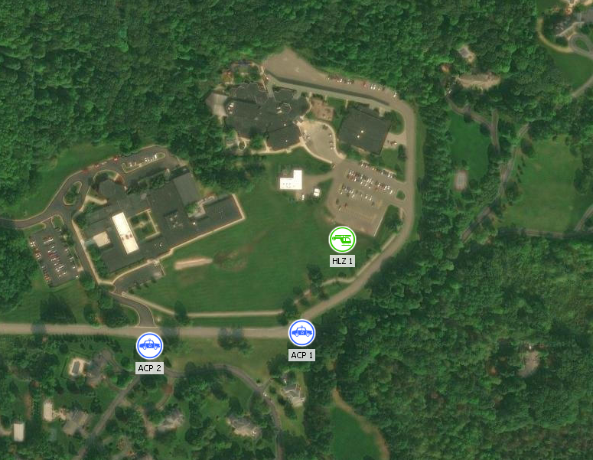
Secondary Landing Zone: Off Site – At North Staging/ICP
- 42.985676 North
- 85.560519 West
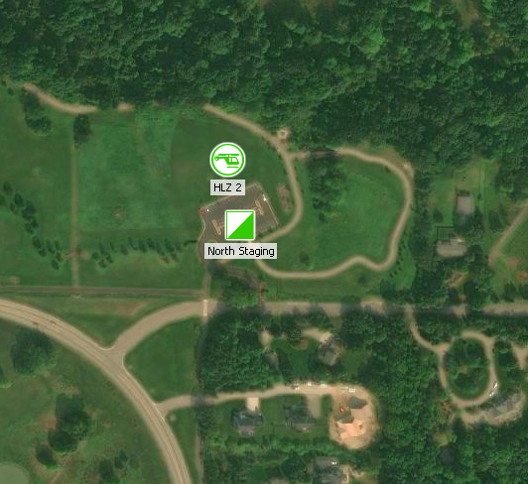

Weather Forecast

Incident Facility Map
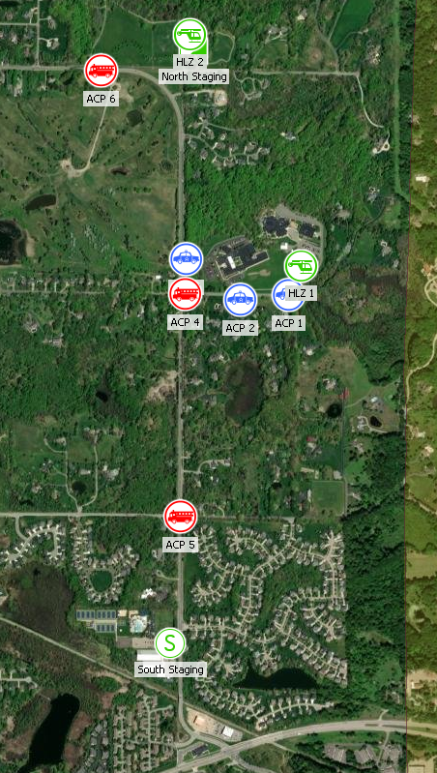

Attachments:
- Attachment A: Lincoln Campus Macro View
- Attachment B: Lincoln School Micro View
- Attachment C: Lincoln Developmental Center Micro View
- Attachment D: Early Childhood Center Micro View

(End of Document)

