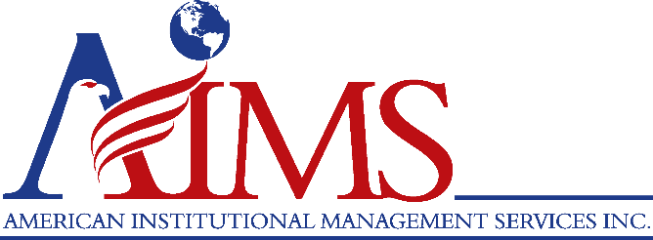
The Dearborn Academy
EMPLOYMENT OPPORTUNITY
Bus Driver/Lunch Aide
The Dearborn Academy · Dearborn, MI | Employer: AIMS | Reports To: Principal
Position Summary
Under supervision, the Bus Driver/Lunch Aide will perform a variety of supportive tasks that may include general maintenance, instructional and food service assistance. The Bus Driver/Lunch Aide will transport students and clients to and from classes, appointments and field trips using company vehicles up to and including a 77-passenger school bus. The Bus Driver/Lunch Aide will perform pre- and post-trip inspections on vehicles and maintain vehicle logs and report safety and maintenance issues to the designated building administrator.
Key Responsibilities
- Pick up and transport children and/or clients to and from the Academy or other approved sites.
- Maintain transportation files on all school bus passengers.
- Establish and maintain two-way communications with campus, teachers and parents.
- Maintain records as required by the Academy.
- Submit reports as required.
- Maintain current required trainings.
- Other driving duties as requested.
- Clean the bus before and after each use.
- Enforce all Academy policies concerning the operation of and riding on the bus.
- Participate in all trainings and in-services relating to job duties.
- Perform other transportation duties as assigned.
- Monitor students during lunch hours and recess as required.
Qualifications
- To perform this job successfully, an individual must be able to perform each essential duty satisfactorily. The requirements listed below are representative of the knowledge, skill and/or ability required.
- High school diploma or GED.
- CDL Class “A,” “B,” or “C,” with a passenger “P” and “S” endorsements and six (6) months experience in driving students and/or clients using at minimum a 17-seat van or bus.
- Maintain skills and licensing necessary to drive the school bus.
- No more than six points on driving record in the last three years.
- No convictions of DUI or reckless driving.
- Experience in food handling or previous work with children is preferred.
- Ability to lift 50 pound containers on a regular basis.
- Ability to read and follow directions.
- Ability to communicate effectively verbally and in writing.
How to Apply
Apply online through the Wayne RESA applicant portal: https://www.applitrack.com/resa/onlineapp/
Learn more: www.thedearbornacademy.org · Résumés to: hr@aimsus.com
The Dearborn Academy and AIMS are equal opportunity employers. Employment is contingent upon satisfactory criminal background and unprofessional conduct checks as required by Michigan School Safety Legislation.

