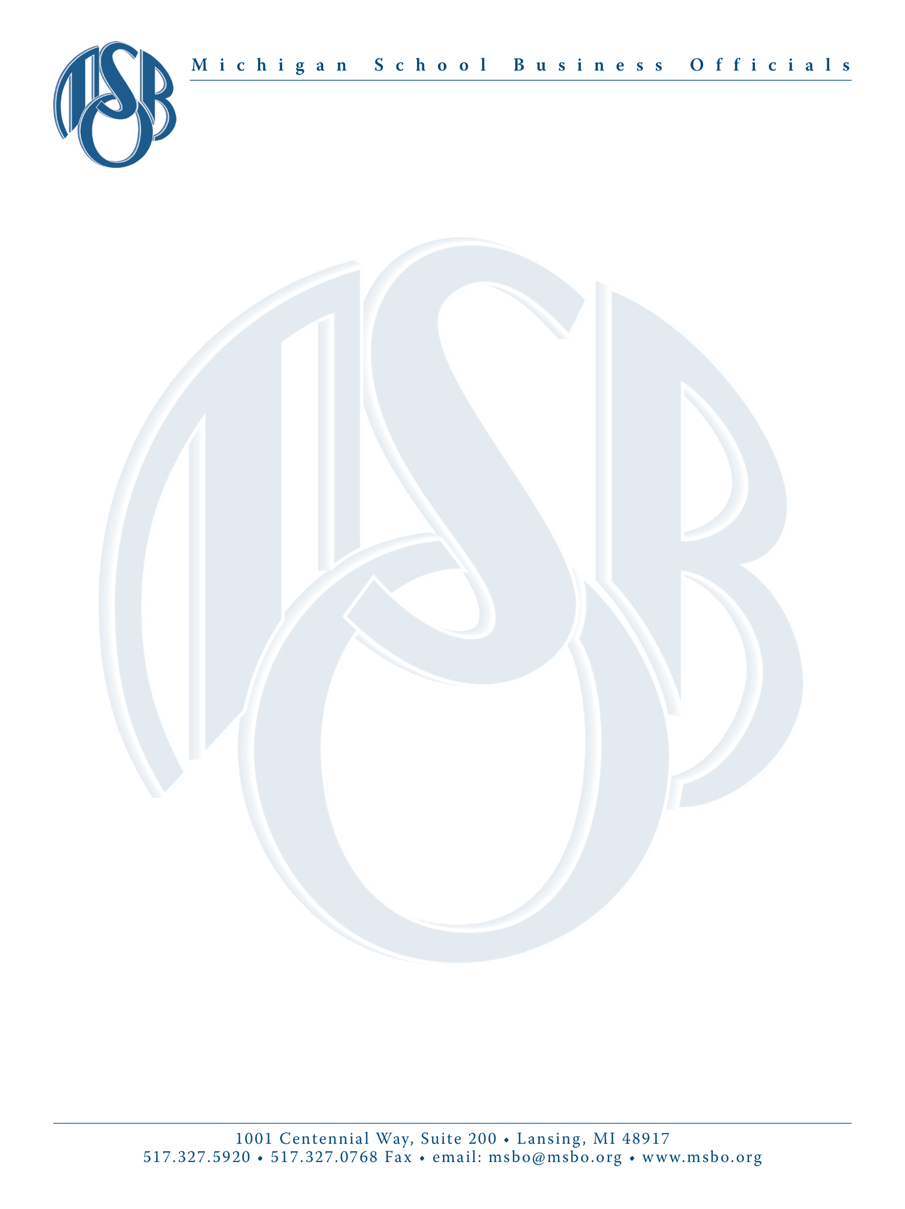

August 29, 2023

Dear MSBO Facility Conference Exhibitor:

Your application for booth rental at the 2023 MSBO Facilities Conference has been received and we look forward to having you with us at Crystal Mountain Resort, Thompsonville, Michigan, October 1-3, 2023. Exhibit show is Monday October 2.

This letter is to provide you with up-to-date conference details and to send you the forms necessary to help us prepare for this event.

COMPANY REPRESENTATIVES. Please complete this form and return it to our office by September 15, 2023. Indicate the names of your representatives to be present at the conference. Also, indicate who will be attending the Networking Luncheon on Monday, October 2nd prior to the exhibit show. See the form for complete details. To order any meal tickets online, use this link.

CONTRACT AGREEMENT. Please complete this form and return it to our office by September 15, 2023. Make sure you read this carefully and complete ALL parts.

DOOR PRIZES. If you would like to donate a prize for the drawings, please complete the enclosed form and return it to our office. If you indicated you are donating a door prize, please bring it with you and keep it in your booth, the winner will come to your booth to claim it.

CONFERENCE INFORMATION. Complete Conference Information, which outlines scheduled conference activities, can be found using the link above. To attend the sessions and meals (unless you purchased meal tickets), you must register as a participant in addition to your exhibit. Please do not schedule activities during scheduled conference time.

EXHIBIT SET-UP. Exhibit set-up is 5:30 – 8:00 p.m. on Sunday, October 1, 2023 and on Monday, October 2nd from 8:00 – 11:30 a.m. Tent booths should not set up Sunday – due to a security issue. Art Craft Display will have qualified personnel available to assist you if needed. If you have any questions, please feel free to contact Art Craft at (616) 791-8024.

SHIPPING DISPLAY ITEMS. If shipping display items, they can be shipped either to Art Craft Display, (MUST BE RECEIVED IN THEIR OFFICE BY 4:00 P.M. ON THURSDAY, SEPTEMBER 28, 2023) or, if you cannot meet this strict deadline, you should send your display directly to the Crystal Mountain Resort. Displays should not arrive more than three (3) days prior to the conference. The shipping address is Crystal Mountain Resort, Attn: Conference Services, 12500 Crystal Mountain Drive, Thompsonville, MI 49683. Make sure that you clearly mark it “HOLD FOR MSBO FACILITIES CONFERENCE OCTOBER 2, 2023”.

NETWORKING LUNCHEON. Come join conference participants for lunch before the exhibit show from 11:40 a.m. – 12:15 p.m. This is a great opportunity for you to socialize with conference participants in a relaxed setting over lunch. Please indicate on your Exhibit Representative Form if you will be attending so we can reserve a lunch for you. There is an additional charge of $32 for each representative (over two per booth) to attend the Networking Luncheon.

EXHIBIT HOURS. The conference program will list the exhibit hours for Monday, October 2, 2023, from 12:15 – 2:15 p.m. At this time, the exhibits will be the only focus. Exhibit breakdown is immediately following at 2:15 p.m.

LOADING/UNLOADING. Please note that there is no loading dock at Crystal Mountain. Equipment should be such that it can be carried or pushed in on carts. The entrance for ALL exhibitors (from the parking lot) is at the back of the large tent. This also includes exhibit booths inside the building.

MSBO Facilities Conference
August 29, 2023
Page 2

HOTEL RESERVATIONS. At this time, Crystal Mountain is full. Please contact the Crystal Mountain Reservations Department at 1-855-520-2974 or email Crystal Mountain at: callcenter@crystalmountain.com to get on a waiting list. Please provide the following information in your email. Subject line – MSBO Waitlist

- Name:
- Email address:
- Phone number:
- Dates of stay:
- How many people, number of adults, kids:
- Type of room needed or number of beds needed:
- How many rooms needed:

Rooms at Crystal Mountain must be booked by August 31, 2023 to receive the special MSBO rate.
Crystal Mountain is working diligently to see if other rooms will be available and will contact you if they have an opening. In the meantime, please book a room at one of the alternative lodging choices. Be aware of their cancellation policy in case you need to cancel and swap your reservation. Here are some alternate hotel options.
- Mountain Valley Lodge – 231-378-2990 (3 miles from Crystal Mountain)
- Harbor Lights Resort in Frankfort – 231-352-9614 (17.7 miles from Crystal Mountain)
- Baymont Inn & Suites – 231-930-4052 (12.9 miles from Crystal Mountain)
- Hotel Frankfort & Restaurant – 231-352-8090 (17.4 miles from Crystal Mountain)
- Bay Port Lodging – 231.399.0156 (16.9 miles from Crystal Mountain)
- Coastal Suites Resort – 231-383-4116 (11 miles from Crystal Mountain)
- Coastal Inn – 231-383-4295 (11.4 miles from Crystal Mountain)
- Crystal Lake Resort – 231-882-7282 (11.4 miles from Crystal Mountain)

SUNDAY WELCOMING RECEPTION. You are invited to join conference participants for a reception on the Conference Center deck Sunday evening from 5:30 -7:00 pm. There will be dinner and drinks at a cost of just $37 per person. This is a great opportunity to renew old friendships and make new ones. See attached form to purchase your tickets, or you can also purchase them online. Be sure to pick up your nametag at the reception – your nametag is your meal/drink ticket.

MONDAY DINNER/RECEPTION. Monday evening at 5:30 pm, we will ride the ski lift (weather permitting) to the top of the mountain for a reception and then return to the Conference Center for dinner at 6:30 pm in Northwest Territories. You are invited to join conference participants on the mountain and for dinner at a cost of just $46 per person. This is another opportunity for you to socialize with customers in a fun relaxed setting. See attached form to purchase dinner tickets or order online.

ADDITIONAL EXHIBIT ITEMS. Please review the information from Art Craft Display, Inc. Go to www.artcraftdisplay.com to obtain forms for optional equipment orders, labor services, shipping, signs and banners. Click on “Get Exhibitor Kit”, our event code is 340182.

BOOTH ASSIGNMENTS. Enclosed is a layout of the exhibit hall and the tents. See attached list of exhibitors and booth numbers for your location.

OUTSIDE BOOTHS. Outside booths will be housed in 30’ x 90’ and 60’ x 120’ heated tents (with sides) located in the parking lot adjacent to the exhibit hall. These booths will receive the same pipe & drape, skirted table, chairs, etc. as regular booth spaces with exception of the tabletops. You have been assigned a specific location – see floorplan and booth listing.

REGISTRATION. Conference registration materials are to be picked up after 9:30 a.m. at the conference on Monday morning, October 2, 2023. The registration desk will be located in the Exhibit Hall (lower level) near the elevator.

ATTENDEE LIST (NEW THIS YEAR). You will receive an electronic copy of the attendee list the week before the Conference. You will NOT get a paper list in the packet you receive at the Conference so make sure to bring a copy with you or save it on your computer/phone for use in tracking potential leads.

We appreciate your participation and look forward to seeing you at Crystal Mountain Resort! If you have any questions, please give me a call at (517) 327-2584 or email: plenneman@msbo.org.

Sincerely,

Patty Lenneman
Exhibit Coordinator

