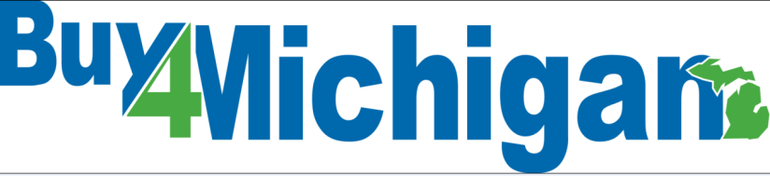 Return completed form to: DMB-vendor@michigan.gov

New Buy4Michigan Organization Information
New System URL |  | Buy4Michigan.com, State of Michigan
General Agency Information |  |  | Please Enter Information Here
Organization name
Address
Address
City, State, Zip
Main Office Phone
Fax Number
Organization URL
Fiscal Year
Fiscal Year Start and End - Month & Day
Fiscal Year Roll Days
Other Key Contacts For This Agency
Primary Organization Administrator (Main Contact):  Authorized user to make department configuration changes |  |  | Name:  Title:  Phone:  E-mail:
Will this person be posting solicitations?
Key Contact /User #2 Information: | Name
 | Title
 | Phone # (include area code and extension)
 | E-mail address
 | Will this person also be an organization administrator?
Key Contact /User #3 Information: | Name
 | Title
 | Phone # (include area code and extension)
 | E-mail address

